# 

# UNIVERSITY OF ILORIN

**DEPARTMENT OF MECHANICAL ENGINEERING**

# A TECHNICAL REPORT ON EXPERIMENT PERFORMED ON

**COMPUTER NUMERICAL CONTROL (CNC)**

**BY GROUP A2**

**COURSE CODE MEE 483**

**DATE OF EXPERIMENT: 31ST JANUARY, 2023.**

**DATE OF SUBMISSION: 9TH FEBRUARY, 2023.**

**TABLE OF CONTENT**

* LIST OF GROUP MEMBERS
* TITLE OF THE EXPERIMENT
* AIM/OBJECTIVES
* APPARATUS AND DIAGRAM
* THEORY
* PROCEDURE
* DATA
* OBSERVATION
* PRECAUTION
* ERROR
* CONCLUSION
* POST LAB ASSIGNMENT

**NAME OF GROUP MEMBERS**

|  |  |  |  |
| --- | --- | --- | --- |
| **S/N** | **NAME** | **MATRIC NUMBER** | **SIGNATURE** |
| 1 | ADEYEMI ABDULBASIT ADEDAYO | 18/30GD011 |  |
| 2 | ADEYIOLA KHALID ADEYEMO | 18/30GD013 |  |
| 3 | AJIBOYE DAVID OLUWATIMILEYIN | 18/30GD019 |  |
| 4 | ABDULAZEEZ ABDULSOMOD AKINTUNDE | 18/30GD001 |  |
| 5 | ABDULRAZAQ ABDULRAHAMN BOLAJI | 18/30GD006 |  |
| 6 | ADENIRAN SHADDAI DANIEL | 19/30GD094 |  |
| 7 | BAKO BOLA MIRACLE | 19/30GD097 |  |
| 8 | ADEGBOYEGA OLUWAFISAYO DANIEL | 18/30GD009 |  |
| 9 | ABIODUN JOSEPHINE OYINDAMOLA | 18/30GD007 |  |
| 10 | AZONDEKON WISTON LIONEEL WADAYI | 19/30GD096 |  |
| 11 | AWOLOLA STEPHEN OLADIPUPO | 18/30GD027 |  |
| 12 | BALOGUN ANIEKAN FAWAZ | 18/30GD031 |  |
| 13 | AMURAWAIYE JOSEPH IFEOLORUN | 18/30GD025 |  |

**TITLE OF THE EXPERIMENT**

AN EXPERIMENT USING THE CNC MACHINE TO PRODUCE STEP SHAFT

**AIMS AND OBJECTIVES**

1. To provide hands-on experience in programming and operating CNC machines.

2. To develop understanding of CNC technology, its applications and the benefits it provides over conventional machining methods.

3. To learn how to interpret engineering drawings, select the appropriate cutting tools and set up the machine for a variety of machining operations.

4. To develop skills in quality control, problem solving, and troubleshooting in CNC operations.

Overall, the main objective of CNC practical is to be equipped with the knowledge and skills necessary to use CNC machines effectively and efficiently in a real-world manufacturing setting

**APPARATUS AND DIAGRAMS**

1. The CNC machines
2. The machine control unit
3. The workplace
4. 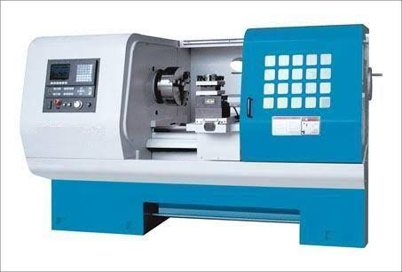The high precision parts.

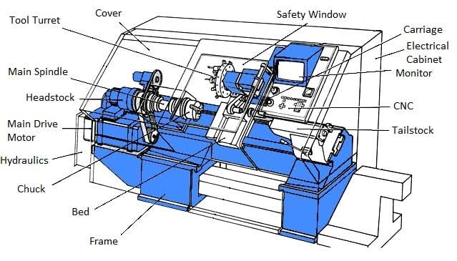

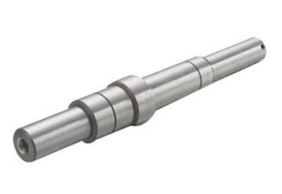

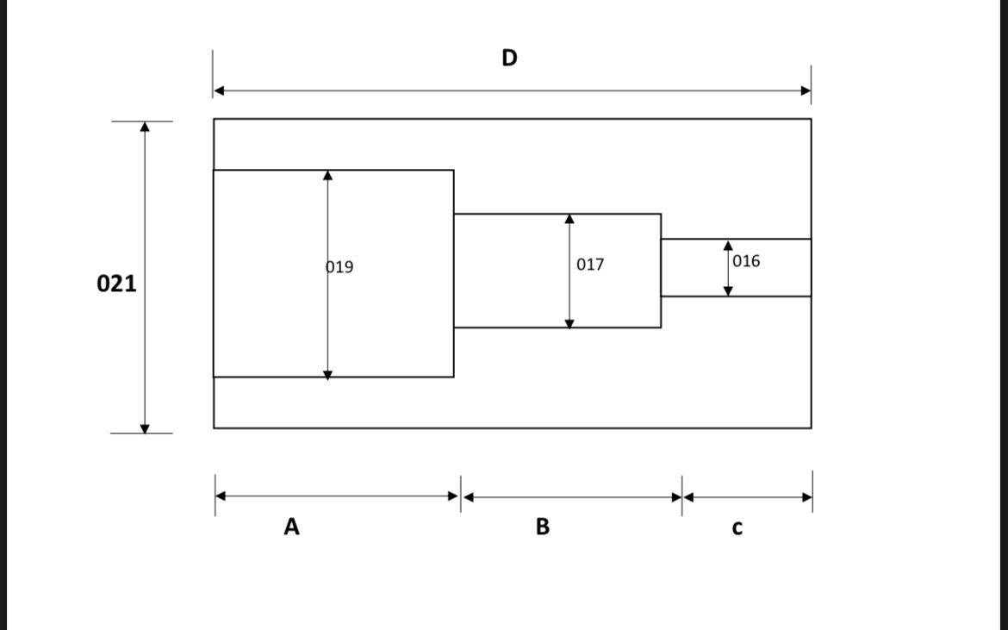

**THEORY**

The advent of technology brought about the use of CNC machines. The fact that programmable machines can do the same if not better mechanical works such as manufacturing etc than human being is not new.

What is CNC machine?

A Computer Numerical Control machine (CNC) is a machine which is highly automated i.e controlled by the computer, in the form of codes which is used in performing different manufacturing processes e.g drilling , cutting milling etc.

CNC machine is the process of using a computer driven machine tool (CNC machine) to manufacture parts of solid materials. This is quick, accurate , and reliable process that bring out the desired manufacturing of a part.

PRINCIPLE OF OPERATION

The CNC depends on the digital instructions usually made on computers aided manufacturing (CAM) softwares e.g solidwork, master cam etc. The software write G-code (Geometry code) that the controller on the CNC machine can read. Then the computer interprets the design and moves the cutting tools and the workpiece on multiple axes to cut the desired shape from the workpiece.

The CNC makes the use of two languages which are the G code and M code. The G code, also called geometry code includes the machine’s movement coordinates so that the machines knows where to cut chips off the part, which tool to use , quickly to move the spindle, the radius of the axes given by the machine and also the speed settings. The M code on the other hand stands for miscellaneous code and coms with the overall G-code , but accounts for different part of the CNC process. It account for when to stop axes or the spindle, when to change the direction.

There are different CNC machine types e.g lathe, drilling, milling, plasma, laser engraver, router machine.

BRIEF DISCUSSION ABOUT THE CNC LATHE MACHINE

It is defined as workable bench whose the workpiece can be clamped with a rotation. The cutting tools can move on various axis to make multiple shapes. Typically, a simple lathe machine can run on X and Z axis. The other position such as Y-axis, sub spindle or different locations are known as turning centers. The CNC lathe has various types of such standard, multi-axis, swiss type, B-axis etc. Also, it has five different kinds based on the axis depiction which are;

1. 2-axis lathe machine
2. 3-axis lathe machine
3. 4-axis lathe machine
4. 5-axis lathe machine
5. Six or more axis lathe machine

ADVANTAGES OF CNC MACHINES

1. It has high precision.
2. High accuracy.
3. It is safe to operate on.
4. High versatile.
5. It can also machine complex manufacturing designs.
6. It is fast and efficient.
7. Production capability is extremely high.
8. It saves time.
9. It is very reliable.

DISADVANTAGES OF CNC MACHINES

1. It is very expensive to purchase.
2. It requires a good technical and knowledgeable operator.
3. Maintenance is inconvenient.

**PROCEDURE**

The students are to write a part program to machine the given component in the diagram, by carefully following the steps and edit as appropriate. Each group is to submit their programme separately together with their machined component. Generate a manual part programme for the part given. Use both roughing and finishing operation to finish the parts. State the geometry of the tool using the given dimension. The detailed procedure is outlined below:

1. Have a sketch of the sample given and the desired result

2. Determine the reference point for the cutting tool of the CNC machine

3. Specify the system of programming to be used (Absolute- G90 or Incremental- G91), type of dimension to be employed (Inch- G70 or metric- G71), unit of feed rate (in mm/min-G94 or mm/rev- G95) as well as the magnitude of the feed rate.

4. Specify the speed rate (rev/min – G97) and the speed value which determines the spindle speed.

5. Input the direction the spindle starts rotation either (clockwise- M03 or anticlockwise- M04)

6. Write down in chronological order, the discrete numerical values(code blocks) governing the operations to achieve the desired result putting into consideration the reference point determined before the start of the machining operation.

7. The maximum allowed depth of cut in a single pass should be taken into consideration so as not to damage the material and the tool.

8. Simulate the code written down in paper on the CNC lathe machine, if you’re satisfied with the results, begin the operation.

9. At the end of the operation, the tool should be moved back to the reference point.

10. Stop the spindle using M05 and terminate the programme with M02

**DATA**

**Program**

1. N010 - G90 G71 G94 F100
2. N020 - G97 S1200
3. N030 - M03
4. N040 - G1X - 34.000, Z - 180.000, F100
5. N050 - G1X - 35.000 F100
6. N060 - G1Z - 330.000 F100
7. N070 - G1X - 34.000, Z - 180.000, F100
8. N080 - G1X - 36.000 F100
9. N090 - G1Z - 270.000 F100
10. N0100 - G1X - 34.000, Z - 180.000, F100
11. N0110 - G1X - 37.000 F100
12. N0120 - G1Z - 220.000 F100
13. N0130 - G1X - 34.000, G1Z - 180.000, F100
14. N0140 - G1X - 38.000 F100
15. N0150 - G1Z - 220.000 F100
16. N0160 - G1X - 34.000, G1Z - 180.000, F100
17. N0170 - M02

**OBSERVATION**

The following were observed during the experiment:

1. The machine does not need much supervision after setting and imputing the G-Code;
2. Once there is an error in the code, the machine notifies it;
3. The machine signifies the reasons of failing answers;
4. The machine is faster and can be used for production in large quantity;
5. The machine can automatically select or change tools when included in the program.

**PRECAUTION**

**Pre-operational safety check**

1. Familiarity with CNC ‘nesting’ and ‘tool-pathing’ software functionality were ensured
2. Location and familiarities with the operation of the ON/OFF and emergency stop controls were ensured
3. Secure of the front guard door and safety devices put I n position.
4. We ensured that the mill cutter bit size and profile conforms to specifications.
5. We make sure that all cutters are sharp and free of resin build up or wear
6. The waste collectors shroud was adjusted (where fitted) correctly for maximum efficiency
7. We were aware of any other personnel in the immediate vicinity and ensured the area is clear before using the CNC machine

**Pre-operational safety check**

1. Never pre-program any CNC mill to perform operations beyond the capacity of the machine
2. Confirm all CNC programming instructions for the mill
3. We ensured that the materials work piece is secured before milling
4. We made sure that the coolant system is operational before milling
5. We ensured that all interchangeable tool head cradle movements remain unobstructed for all operations
6. We made sure not to leave the CNC mill in operational mode while unattended

**ERRORS**

1. Inaccuracy in the design of the fixture
2. Imprecision in the shape of cutting tools
3. Issues with positioning
4. Factors causing force and deformation within the production system
5. Thermal changes affecting the production system
6. Measurement inaccuracies
7. Inconsistencies in the adjustment process
8. Internal stress levels
9. Deficiencies in the manufacture of the machine tool

To mitigate these errors, manufacturers employ various quality control measures including monitoring temperature and stress during production, utilizing high precision features and measuring tools, and regularly maintaining and calibrating equipment.

**CONCLUSION**

From the experiment, we understood the principle of CNC machine better, and learnt the mode of operations of the machine. The machine can automatically selector change tools when included in the program. We also learnt the G and M codes which are used for preparatory and miscellaneous functions respectively in part programming to carry out work on the machine. The G codes are instructions for the CNC machine to operate without human intervention. Also, zero set up is one of the important steps to obtain accurate geometry of the workpiece.

We also learnt about the applications of the CNC machine and its advantages over the lathe machine. Therefore, it can be concluded that the objectives of this experiment was achieved.